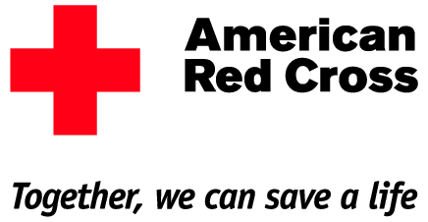

**2018 Spiritridge Mini-Skills Olympics**

Students -- Come participate in the 2018 Spiritridge Mini-Skills Olympics, a fundraiser sponsored by the Panther Leadership Club.   
Registration **fees** will be **donated** to the **American Red Cross**.

Mini-Skills Olympic Stations Include:

Basketball, Hockey, Football, Soccer, Corn Hole Toss and Running

Adult Volunteers Needed!

Please contact: Ms. Gordon at gordonm@bsd405.org

Date: Friday, May 18, 2018

Time: 5:00 PM – 8:00 PM

Place: Spiritridge Elementary Field and MPR  
A **parent or guardian** will need to be present with their child/children during the Spiritridge Mini-Skills Olympics Event. Registration form(s) and fees are due no later than Wednesday, May 9, 2018. All Spiritridge students will bring home a registration form on April 27.

Sense of Belonging